Python Programming

Experiment Report

Name DIO STANIA ADINATA
Student Number
Major Software Engineering
Class 2023

2022

Experiment 7

- Experimental Purpose
Experiment 6 aims to deepen the understanding of Python programming through the following objectives:
  - Master the usage of member method and member attributes of class in python through coding.
  - Master the usage of random Module by writing codes.
  - Master the usage of math Module by writing codes.
  - Master the usage of database programming.
  - Master the usage of Scientific computing
- Experiment Content
  - Objective1: Random Integer List with Selective Sorting
    - Design thought
I plan to create a list of 28 random integers is generated using random.randint(). The program then iterates over the list and extracts the elements at odd indices (1, 3, 5, …) into a separate list, that list will be sorted in ascending order, and places the values back into the original odd‑index positions. Even‑index elements will remain unchanged..
    - Source Code
import random

random_list = [random.randint(0, 100) for _ in range(28)] print("Original list:")
print(random_list)

odd_index_values = [random_list[i] for i in range(1, len(random_list), 2)]
odd_index_values.sort()

for i, val in enumerate(odd_index_values):

random_list[1 + i*2] = val

print("\nModified list (odd indices sorted):") print(random_list)
    - Experiment Result
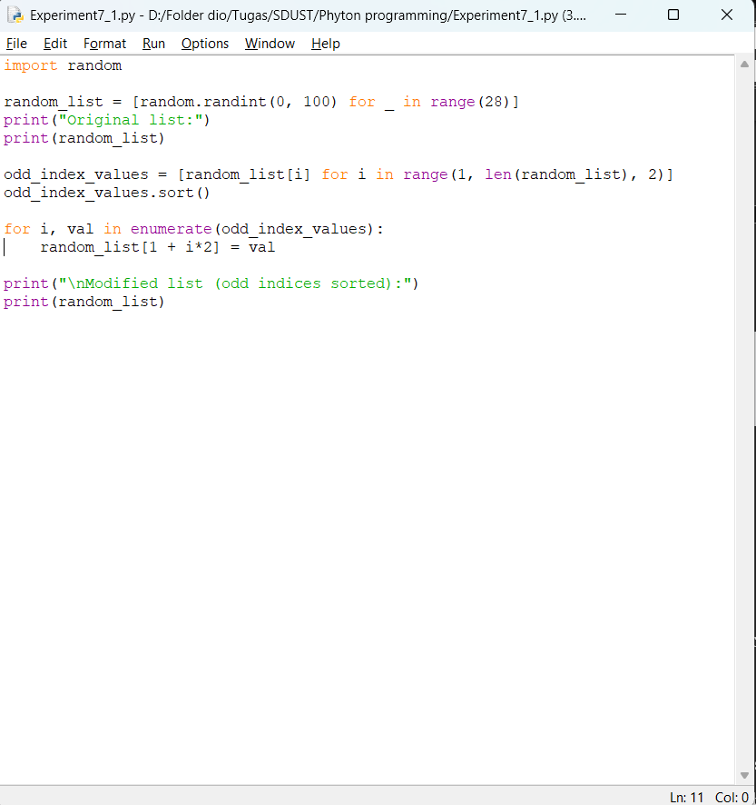

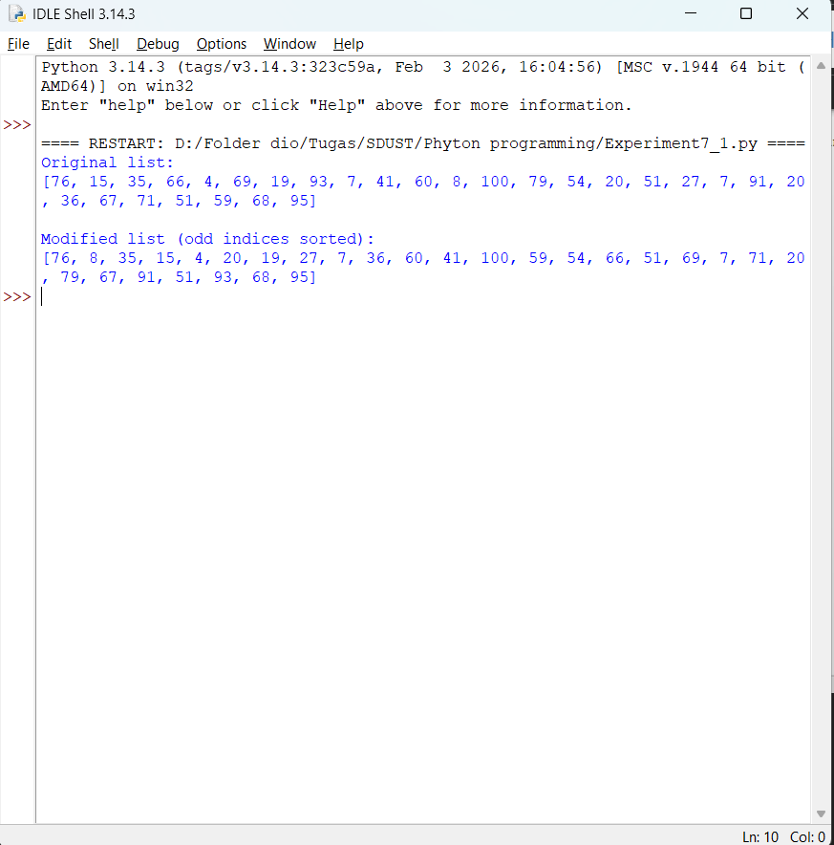

  - Objective2: Mathematical Calculations with π and e
    - Design thought
I plan to using the math module, the program retrieves the constants math.pi and math.e. It calculates π4+π5π4+π5 and e6e6, then subtracts the second result from the first. The final result is printed.
    - Source Code
import math

pi = math.pi e = math.e

result1 = pi**4 + pi**5 result2 = e**6
difference = result1 - result2

print(f"π^4 + π^5 = {result1}") print(f"e^6 = {result2}")
print(f"(π^4 + π^5) - e^6 = {difference}")

    - Source Code
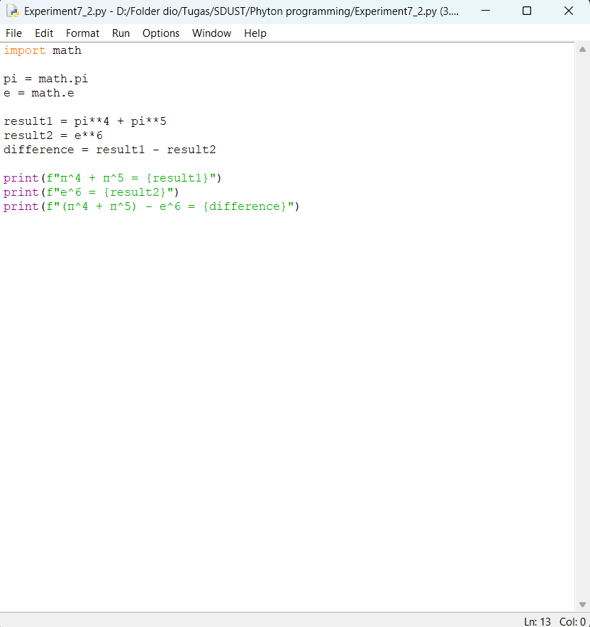
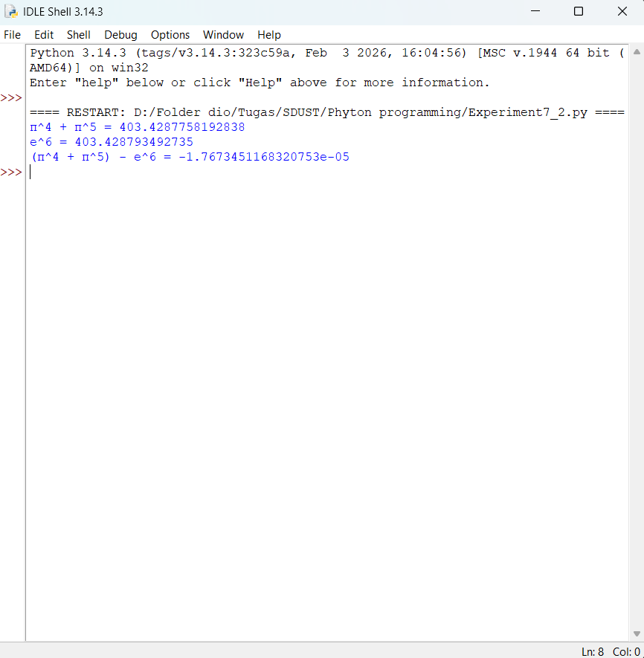

  - Objective3: Student Class Definition and Instance Creation
.1. Design thought

I plan to create a Student class is defined with attributes name and score. The constructor ( init ) initializes these attributes. Two instances are created: "Tommy" with score 72 and "Emma" with score 89. A method display_info() prints the student’s information.
  - Source Code
class Student:
def init (self, name, score): self.name = name
self.score = score

def display_info(self):
print(f"Student: {self.name}, Score: {self.score}")

student1 = Student("Tommy", 72) student2 = Student("Emma", 89)

student1.display_info() student2.display_info()
  - Experiment Result
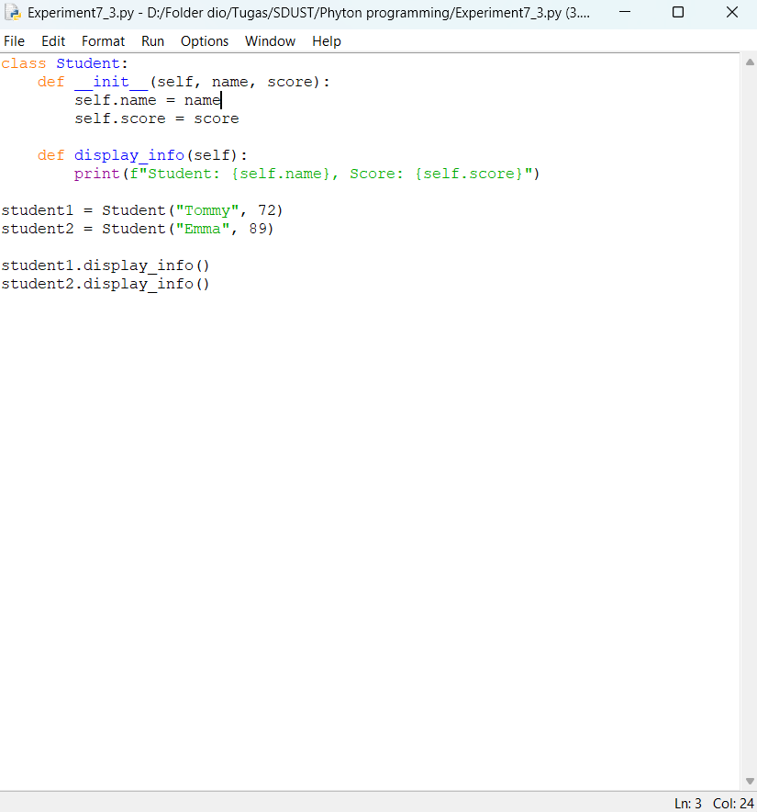

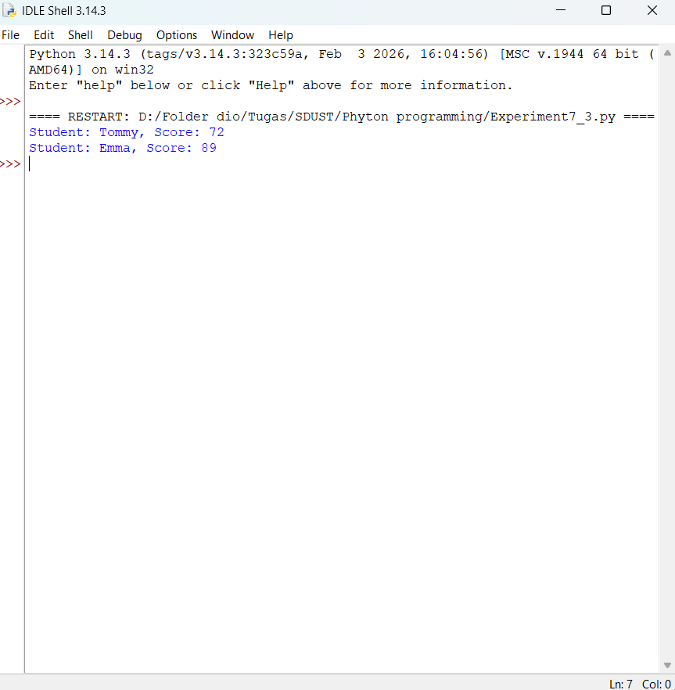
  - Objective4: SQLite3 Database Operations
    - Design thought
I plan to create a program uses Python’s built‑in sqlite3 module. It connects to a database file student.db, creates a table student with the specified fields, inserts five student records, queries and prints all data, updates the age of a specific student, deletes a student by ID, and finally closes the connection. Error handling is included to ensure the database is closed properly.
    - Source Code
import sqlite3

# Connect to database
conn = sqlite3.connect("student.db") cursor = conn.cursor()

# Create table cursor.execute("""
CREATE TABLE IF NOT EXISTS student (
id INTEGER PRIMARY KEY AUTOINCREMENT,
name TEXT,

age INTEGER,
major TEXT
) """)

# Insert 5 student records students = [
("Dio", 20, "Computer Science"),
("Fina", 22, "Mathematics"),
("Rifath", 21, "Physics"),
("Adel", 23, "Chemistry"),
("Jogi", 19, "Biology")
]
cursor.executemany("INSERT INTO student (name, age, major) VALUES (?,
?, ?)", students) conn.commit()

# Query and print all students cursor.execute("SELECT * FROM student") rows = cursor.fetchall()
print("All students:") for row in rows:
print(row)

# Update age of student with name 'Fina' to 25 cursor.execute("UPDATE student SET age = 25 WHERE name = 'Fina'") conn.commit()
print("\nAfter updating Fina's age:") cursor.execute("SELECT * FROM student") for row in cursor.fetchall():
print(row)

# Delete student with id = 3 cursor.execute("DELETE FROM student WHERE id = 3") conn.commit()
print("\nAfter deleting id=3:") cursor.execute("SELECT * FROM student") for row in cursor.fetchall():
print(row)

# Close connection conn.close()
    - Experiment Result

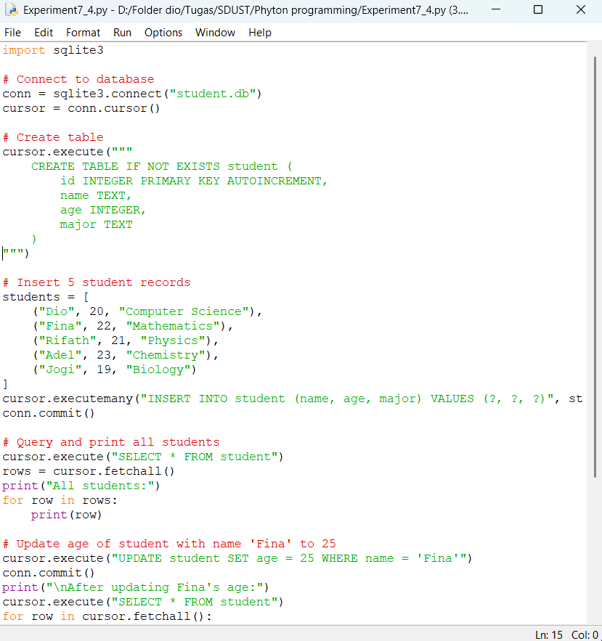
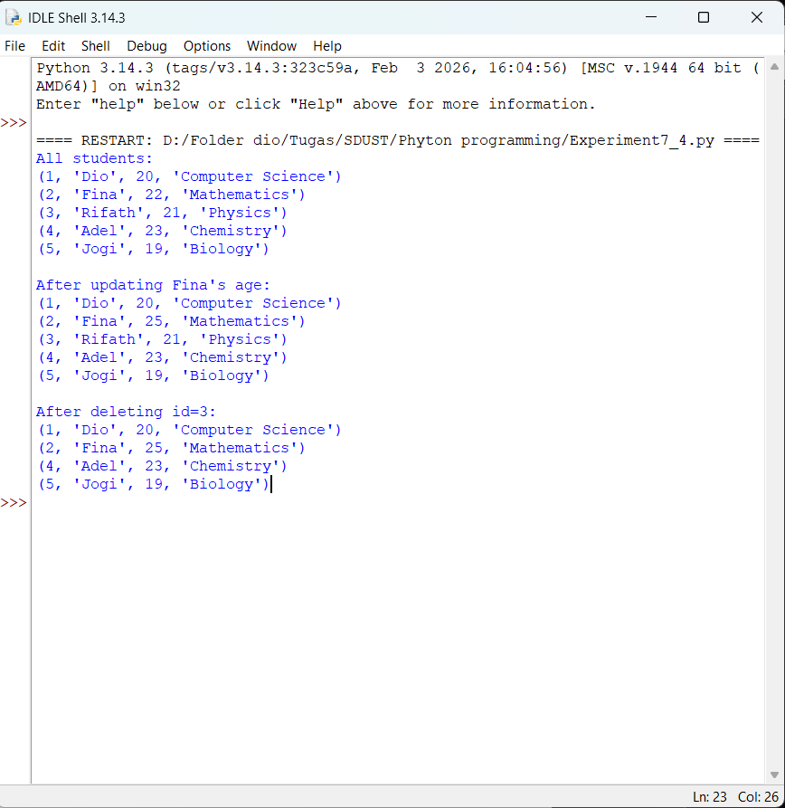

  - Objective5: NumPy Student Score Analysis
    - Design thought
I plan to create a program using NumPy, a 5×4 array is created from the given score list. The program then computes:
      - Average, highest, and lowest score for each course (column)
      - Total and average score for each student (row)
      - All scores ≥ 90
      - Replacement of scores < 60 with 60
      - Sorting the array descending by the first column (Chinese scores)
All operations are performed using NumPy functions without Python loops.

    - Source Code
import numpy as np
scores = np.array([
])
print("Original scores:\n", scores)
# Per-course statistics
course_avg = np.mean(scores, axis=0) course_max = np.max(scores, axis=0) course_min = np.min(scores, axis=0) print("\nPer-course average:", course_avg) print("Per-course highest:", course_max)
print("Per-course lowest:", course_min)
# Per-student total and average
student_total = np.sum(scores, axis=1) student_avg = np.mean(scores, axis=1) print("\nPer-student total:", student_total) print("Per-student average:", student_avg)

[85, | 92, | 78, | 90],
[91, | 88, | 95, | 86],
[76, | 65, | 80, | 72],
[88, | 94, | 89, | 93],
[82, | 79, | 85, | 81]

# Find all scores >= 90 high_scores = scores[scores >= 90]
print("\nScores >= 90:", high_scores)

# Replace scores < 60 with 60 scores[scores < 60] = 60
print("\nAfter replacing <60 with 60:\n", scores)

# Sort descending by first column (Chinese scores)
sorted_indices = np.argsort(scores[:, 0])[::-1] # descending order sorted_scores = scores[sorted_indices]
print("\nSorted by Chinese scores (descending):\n", sorted_scores)
    - Experiment Result
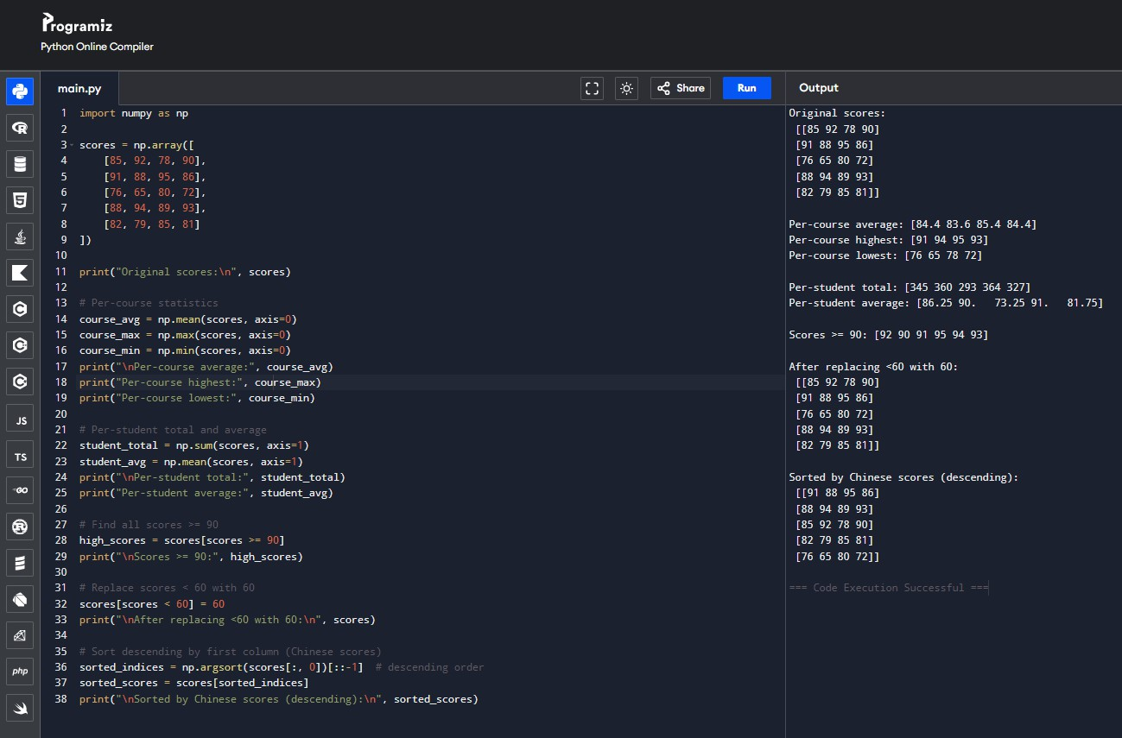

- Experiment Conclusion
What did you learn from the experiment?
From this experiment I learned several important concepts in Python programming. I learned how to use the random module to generate lists of random integers and

perform selective sorting based on index parity. I also learn on how to use the math module, to performed calculations with π and e. I also practiced database programming with SQLite3, including creating tables, inserting, querying, updating, and deleting records while managing connections properly and using NumPy to perform vectorized operations to analyze a 2D array of scores, compute statistics, filter values, replace elements, and sort rows without writing explicit Python loops.

